**Task Management System**

PROBLEM STATEMENT:

The problem statement is to create a full stack project for students/workers being in a right balance between studies, college works and leisure time.

ABSTRACT:

This project offers the improvement of a strong Task Management System using modern-day internet technologies which is based on a CRUD authentication, using Next.js, React, Prisma, and MongoDB. The objectives to streamline and decorate undertaking organisation, collaboration, and tracking for people or groups in numerous settings.

Key features of the Task Management System include:

1. **User-Friendly Interface:** provides an intuitive and user-friendly interface, ensuring easy adoption across various levels of expertise within the organization. The design focuses on simplicity.

2. **Task Creation and Assignment:** create tasks, set priorities, deadlines, and assign responsibilities to individuals or teams. The system supports the attachment of relevant documents and provides a clear overview of task details.

3. **Real-time Collaboration:** real-time collaboration by enabling seamless communication between team members. Integrated messaging and commenting features allow for quick updates, discussions, and feedback related to specific tasks, enhancing overall teamwork.

4. **Progress Tracking and Analytics:** Users can monitor the progress of tasks through comprehensive tracking and analytics tools. The system provides insights into task completion rates, time taken.

5. **Customization and Integration:** designed to be adaptable to diverse organizational structures and workflows. It supports customization of task categories, tags, and project hierarchies. This feature helps in minimizing delays and improving overall task accountability.

6. **Security and Access Control:** Security is a top priority, and incorporates access controls and encryption protocols to safeguard sensitive information. User roles and permissions can be configured to ensure data privacy.

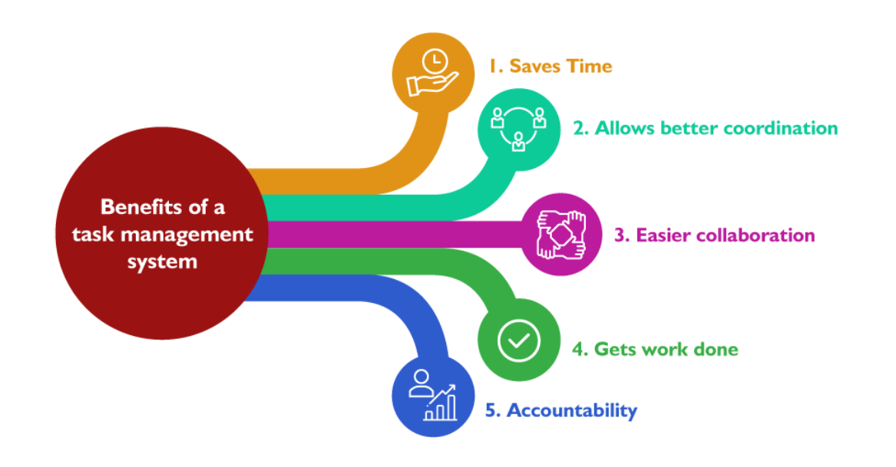

This Task Management System serves as a complete solution for individuals and groups looking for an efficient and user-friendly platform for organizing and coping with obligations. The mixture of Next.Js, React, Prisma, and MongoDB gives a effective and scalable architecture, making sure a strong foundation for the improvement of modern-day internet programs.

By,

MRISHIKA DHINAKARAN

RA2211026050061 B.TECH CSE AIML-B